Seismic Medicine

Accelerometers and Machine Learning Peek Inside Your Neck

The Problem:

Take a day in the life of my third grade teacher, Mrs. Bungee. School is almost over. She is way beyond the breaking point. All day she has been trying to calm down her students, maybe try to get them to stop talking when she’s talking, only to eventually have to concede defeat and elevate her voice to overcome the chatter. Perhaps she had yard duty today - tasked with the everlasting duty of shouting at the boys for chasing the girls cross the playground - or maybe the students were being particularly argumentative about a new teaching method she thought to try out.

Either way, her voice has been pushed all day, and she’s starting to feel the same old symptoms: soreness, tiredness… it’s taking more and more effort to output at the same volume, and she’s left silently praying none of the children cause too big a stir, holding out hope she’ll get out of raising her voice again today. The days of her playing the piano and singing to the class might be coming to an end, if this keeps up much longer.

Or, take my seventh grade acting techniques teacher, Mrs. Adam. She has a long history of vocal performance, but the countless hours in front of the microphone have finally gotten to her. For her, vocal hyper exertion has taken its toll in a permanent way, and she has been left forever raspy, with no hope of any future voice based gigs. While she enjoys her new job as an acting teacher, it isn’t hard to see that she wishes she had caught her vocal condition early, in hope that she might have been able to keep the damage from developing to the point it is at now.

These problems are in no way unique to my two teachers, or even teachers in general. It is estimated that over 30% of adults have experienced vocal conditions stemming from overexertion, with about 7% experiencing some vocal troubles at any given point in time (Mehta et al. 2015). These rates only grow when you look professions such as teachers, singers, and nurses. And while remedies do exist, it can be hard to get properly diagnosed, as a diagnosis requires specialists and complicated apparatus that are always inconvenient to access for the standard working adult, and its especially hard to get people to seek help when they themselves might not know that there’s help out there, or that they need it in the first place.

So What’s Being Done?

Fortunately, the medical industry has in fact been working on this problem, and there exist treatment programs that can take a patient’s voice, once in a state of constant tiredness, to being indistinguishable from any normal person’s (Ghassemi 2015). The recovery process itself isn’t complicated: after being diagnosed, a patient will see a vocal therapist for a few appointments and practice various vocal exercises to strengthen the vocal cords and rehabilitate a person’s speaking ability.

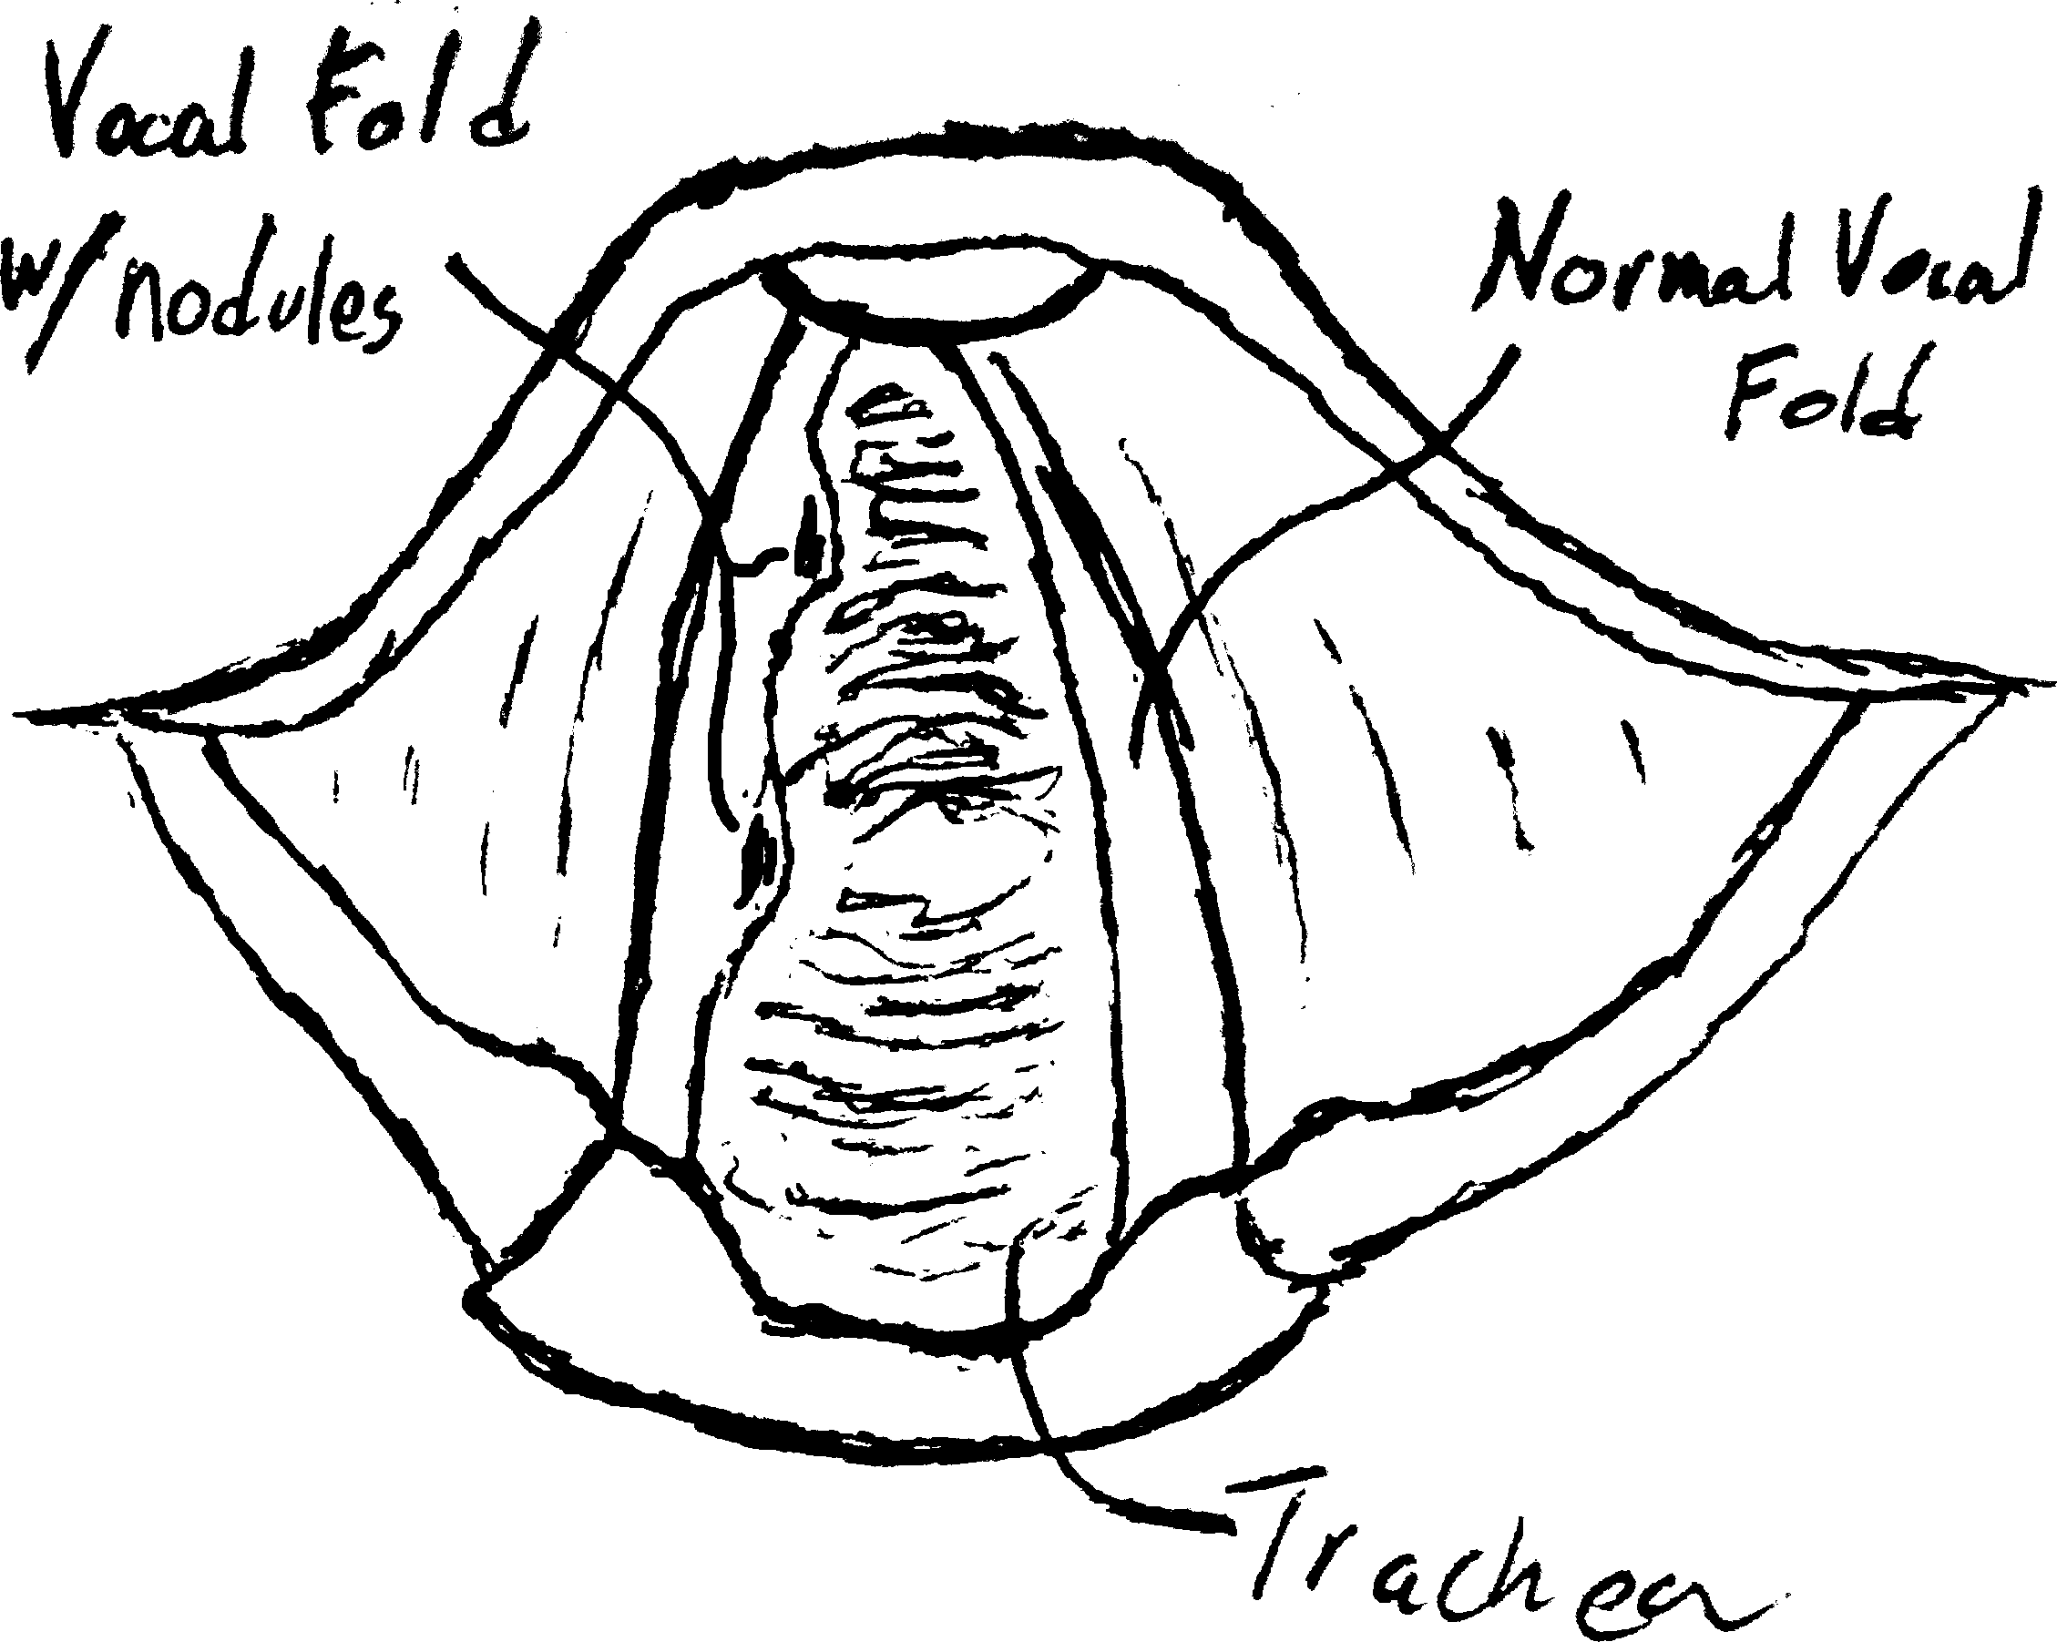Unfortunately, the diagnosis process for these conditions has historically been overly complicated, with various needed trips to specialists and long appointments involving complicated apparatus to measure all sorts of possibly relevant data, sometimes even such invasive procedures as forcing telescopic tubes down a patient’s throat to visually examine the vocal cords for the tell tale “vocal fold nodules”, small lumps (as pictured) on the sides of a persons vocal cords (Ghassemi et al. 2013). However, while these lumps work as smoking guns for critical vocal damage, they are only present in the most extreme cases, causing diagnosis to not be as a simple peek.

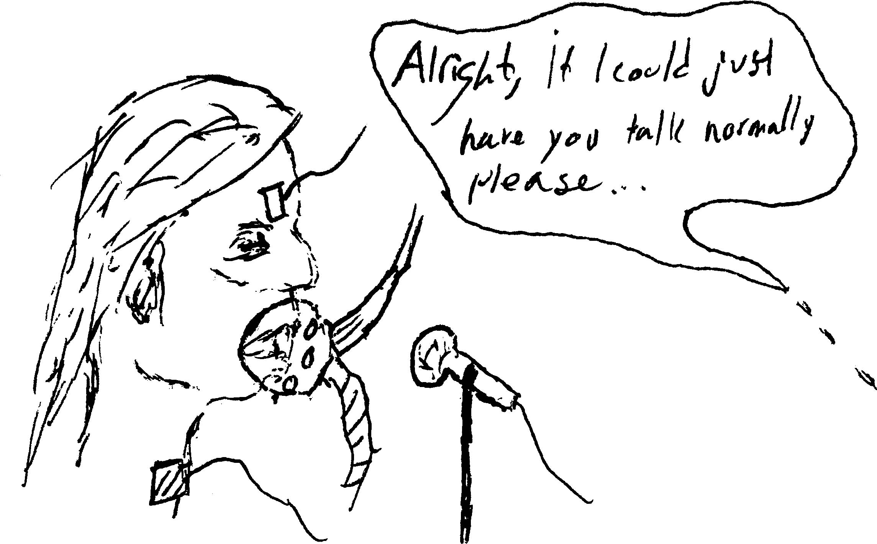In the end, the current diagnosis process presents a few major problems: first and foremost, the invasive procedures and large difficulty in accessing a specialist who is able to diagnose an individual present a huge barrier for the layperson to get the medical diagnosis and treatment they need. The second problem is subtler, up until a patient finds himself or herself in the doctor’s chair, being forced to talk ‘normally’ with all that equipment on their face: it turns out that it is simply impossible to get an accurate measure of a person’s day-to-day vocal state from a single, or even multiple, short, out of the norm, appointments (Ghassemi et al. 2013).

In short: doctors are faced with the impossible: to accurately and efficiently inspect vocal cords over a long period of time, from days to weeks, in such a way that the patient is able to act and talk completely normally (and privately) while being investigated constantly.

Achieving the Impossible:

Luckily, where classical medicine falls, modern technology steps up to take its place. Through leveraging the constant presence of technology in day-to-day lives, researchers have been able to develop techniques that rely not on the measurements from many different apparatus over a short period of time, but rather an investigation of at long-term measurements taken by a single instrument: a simple neck mounted accelerometer, with data collection facilitated by something nearly everyone has access to: a smartphone app (Ghassemi et al. 2013).

Via the accelerometer, researchers are able to measure metrics about the vibrations of a person’s vocal cords such as vocal frequency, the total distance traveled by the vocal cords in a given time frame, and various characteristics of the actual shape of a person’s vocal pressure waves, such as weather there is more of an emphasis at the beginning of the pulse or the end, or maybe it is evenly balanced throughout (Ghassemi et al. 2013).

Researchers recorded over 15,345 five minute windows of accelerometer data, collected from 12 persons evaluated positively for vocal disorders, and their 12 corresponding normal counterparts, controlled for age and occupation (Mehta et al. 2015). As one can imagine, with this amount of data, there is no way to simply look at the results and figure out a correlation in one’s head. This is where the Machine Learning comes in.

Machine Learning: Kindergarten for Computers?

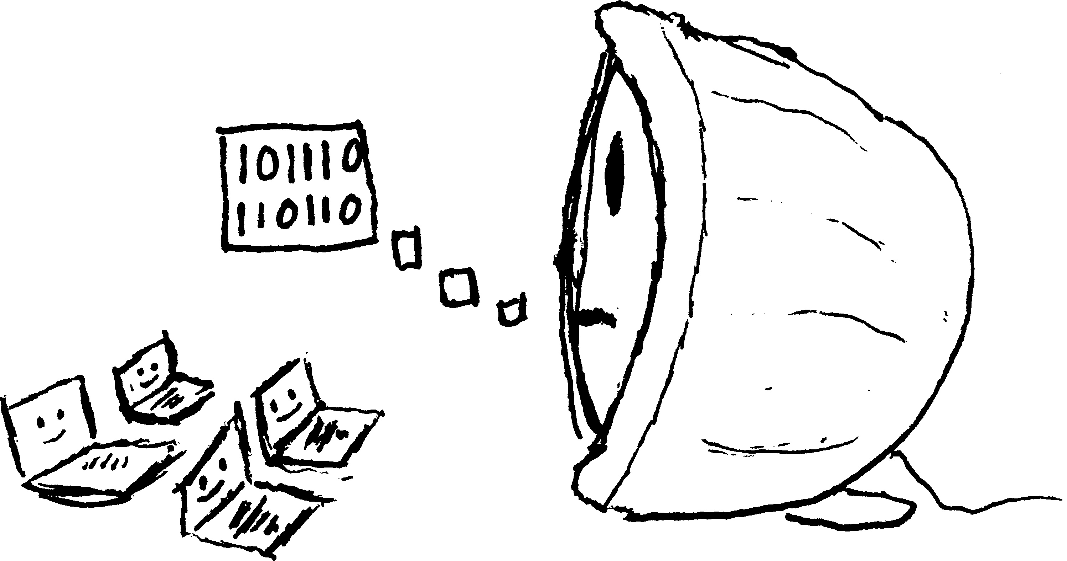The phrase Machine Learning gets thrown around so much nowadays, it almost ranks up there with such buzzwords as “The Cloud” or “Across all your Devices”. But for Machine Learning, the actual definition isn’t nearly as obvious. To those that don’t know, it might sound almost like we’re teaching computers just as one might teach a kindergartener how to read or write. Interestingly enough, for some machine learning applications, that’s actually exactly what’s happening.